**WAREHOUSE MANAGEMENT**

**A PROJECT REPORT SUBMITTED TO**

**SRM INSTITUTE OF SCIENCE & TECHNOLOGY**

**IN PARTIAL FULFILMENT OF THE REQUIREMENTS FOR THE**

**AWARD OF THE DEGREE OF**

**BACHELOR OF COMPUTER APPLICATIONS**

**BY**

**JORDAN GEORGE ABRAHAM**

**RA1931241010107**

**UNDER THE GUIDANCE OF**

**Mrs. R ANITA JASMINE M.C.A., M.E.**

****

**DEPARTMENT OF COMPUTER APPLICATIONS**

**FACULTY OF SCIENCE AND HUMANITIES**

**SRM INSTITUTE OF SCIENCE & TECHNOLOGY**

**Kattankulathur - 603203**

**Chennai, Tamilnadu**

**April - 2022**

**BONAFIDE CERTIFICATE**

This is to certify that the project report entitled "**WAREHOUSE MANAGEMENT**" is the bonafide work of **JORDAN GEORGE ABRAHAM**  (**RA1931241010107**) who carried out the project under my supervision for the award of the Degree of Bachelor of Computer Applications. To our knowledge the work reported herein is the original work done by this student.

**Ms.R Anita Jasmine** D**r. S. Albert Antony Raj**

Assistant Professor , Deputy Dean & Head,

Department of Computer Applications Department of Computer Applications

(GUIDE)

**Internal Examiner**  **External Examiner**

**ACKNOWLEDGEMENT**

With the profound gratitude to the **ALMIGHTY** I take this chance to thank

people who helped me to complete this project.

I take this as a right opportunity to say THANKS to my **parents** who are

there to stand with me always with the words "YOU CAN".

I am thankful to **Dr. T. R. Paarivendhar**, Chancellor, SRM Institute of Science & Technology who gave me the platform to establish myself to reach greater heights.

I earnestly thank **Dr.A.Duraisamy,** Dean, Faculty of Science and Humanities, SRM Institute of Science & Technology who always encourage us to do novel things.

I express my sincere thanks to **Dr. S. Albert Antony Raj M.Sc., M.Phil**., **Ph.D.** Deputy Dean, Department of Computer Applications, for his valuable guidance and support to execute all incline in learning.

It is my delight to thank my project guide Ms.R.Anita Jasmine M.C.A.,M.E., Assistant Professor, Department of Computer Applications for the help, support, encouragement, suggestions and guidance throughout development phases of the project.

I convey my gratitude to all the faculty members of the department who extended their support through valuable comments and suggestions during the reviews.

A great note of gratitude to friends and people who are known and unknown to me who helped in carrying out this project work a successful one.

**JORDAN GEORGE ABRAHAM**

**INDEX**

**Page No.**

**1.Introduction**

1.1Background Information and Motivation 5

1.2 Objectives 7

**2.Software Requirement Analysis**

2.1 Hardware Specification 9

2.2Software Specification 10

**3.System Analysis**

3.1Existing System 13

3.2Proposed System

3.3Feasibility Analysis 14

**4.System Design**

4.1 DFDs diagrams 17

4.2 UML diagrams 20

4.2.1Class Diagram 21

4.2.2 Use Case Diagram 22

4.2.3 Activity Diagram 23

4.2.4 Sequence diagram 25

4.5 Component Diagram 26

4.2.6 ER Diagrams 27

**5.Coding**

5.1 Coding Language and module

5.1.1 Coding language 29

5.1.2 Module 30

5.2 Function in code 33

**6.Testing**

6.1Test login employee 37

6.2Generate Qr Code

6.3Scan Qr code

1. **Output Screens** 39

1. **Conclusion** 49

1. **Further Enhancements** 51

**Bibliography** 53

**ABSTRACT**

This project examines Warehouse Management System (WMS) practices and their effects on operations. This study analyses the relationship between adoption of WMS to its impacts on business performance and competitive advantage of a regional distribution centre. In terms of business performance, the focus is placed on various competitive cores of distribution centre. WMS was found as a positive impact on companies' performance on operations management measures. To adopt the MIS, wireless QRcode embedded WMS in specific, it is necessary to have corporate culture that supports complex operational activities. WMS implementation is crucial in bringing cost reduction in operational level, effective management in management level, as well as improvement of the company's competitiveness in strategic level. Companies that manage warehousing of their products are expected to implement WMS in order to maintain their competitive edge in the global market place.

The Warehouse Management System is a real-time warehouse database capable of handling large inventories of an organization. This can be used to track the inventory of a single store, or to manage the distribution of stock between several stores of a larger franchise. However, the system merely records sales and restocking data and provides notification of low stock at any location at a specified interval. The goal is to reduce the strain of tracking rather than to handle all store maintenance. The main goal of Warehouse Management System is to ensure consistent availability of supplies for consumers. Thus, Warehouse Management System is directed toward owners of small to large stores and stock managers who are responsible of maintaining sufficient goods on hand in a retail or manufacturing business. It can scale from a single computer running both client and server software up to multiple stores and warehouses.The system is also capable of tracking In & Out transaction of single or multiple stores as well as also generates their billing details. The system generates monthly reports of sales from which a manager of a respective store would be able to know the monthly sales transaction done. Warehouse Management system is a Desktop application.

**CHAPTER 1**

**INTRODUCTION**

**1.Introduction**

* 1. **Background Information and Motivation**

Availability of information technology will enable accessibility of more efficient communication and control, which is essential to a competitive global logistics capability. The impetus for strategic use of Management Information System (MIS) has been highlighted as the world transits into a global village. There is growing research interest in the use of MIS as a strategic weapon by organizations. Globalization and competitive pressures have heightened the impetus for strategic use of MIS. More specifically, Warehouse Management System (WMS) designed to introduce improvement into every aspect of a company’s warehouse operations offers an organized approach to manage efficiency. QR code data collection solutions for warehouse management system provides powerful and flexible automatic identification system that connects the shop floor to the enterprise software. By integrating advanced radio frequency and QR coding technologies with core warehousing functionality, WMS provides comprehensive fulfillment centre and warehouse management, including receiving, stocking, picking and related warehouse tasks. The best-of-breed solution leverages state-of-the-art technology to deliver all of the functionality needed to maximize operational efficiency and increase throughput, thus meet the primary focus of warehouse in accuracy and timely fulfillment of customer Orders.

Warehouse can play a key role in the integrated logistics strategy and its building and maintaining good relationships between supply chain partners. Warehousing affects customer service stock-out rates and firm’s sales and marketing success. A warehouse smoothness out market supply and demand fluctuations. When supply exceeds demand, demand warehouse stores products in anticipation of customer’s requirements and when demand exceeds supply the warehouse can speed product movement to the customer by performing additional services like marking prices, packaging products or final assemblies. Warehousing can be defined as a location with adequate facilities where volume shipments are received from production center, which are then broken down in to particular order and shipped onwards to the customer.

Warehousing is an integral part of any logistics system. The warehouse is a link between producer and customer. Warehouse Management provides the insight into your inventory and the warehouse management tools to help you increase customer satisfaction and reduce costs. Warehouse Management exchanges information with many other functional areas in the solution including Logistics, Production and Trade, to help improve your overall business performance. Warehouse Management is used to optimize Inventory, Labor, Physical Space, and Time.

**1.2 Objectives**

**Seasonal production:** The agricultural commodities are harvested during certain seasons, but their consumption or use takes place throughout the year. Therefore, there is a need for proper storage or warehousing for these commodities, from where they can be supplied as and when required.

**Seasonal demand:** There are certain goods, which are demanded seasonally, like woolen garments in winters or umbrellas in the rainy season. The production of these goods takes place throughout the year to meet the seasonal demand. So, there is a need to store these goods in a warehouse to make them available at the time of need.

**Large-scale production:** In case of manufactured goods, the production takes place to meet the existing as well as future demand of the products. Manufacturers also produce goods in huge quantity to enjoy the benefits of large-scale production, which is more economical. So the finished products, which are produced on a large scale, need to be stored properly till they are cleared by sales.

**Quick supply:** Both industrial as well as agricultural goods are produced at some specific places but consumed throughout the country. Therefore, it is essential to stock these goods near the place of consumption, so that without making any delay these goods are made available to the consumers at the time of their need.

**Continuous production:** Continuous production of goods in factories requires adequate supply of raw materials. So, there is a need to keep sufficient quantity of stock of raw material in the warehouse to ensure continuous production.

**Price stabilization:** To maintain a reasonable level of the price of the goods in the market there is a need to keep sufficient stock in the warehouses. Scarcity in supply of goods may increase their price in the market. Again, excess production and supply may also lead to fall in prices of the product. By maintaining a balance in the supply of goods, warehousing ensures price stabilization.

**CHAPTER 2**

**SOFTWARE REQUIREMENT ANALYSIS**

1. **Software Requirement Analysis**
   1. **Hardware Specification**

The Software Requirements Specification is produced at the culmination of the analysis task. The function and performance allocated to software as part of system engineering are refined by establishing a complete information description, a detailed functional and behavioral description, an indication of performance requirements and design constraints, appropriate validation criteria, and other data pertinent to requirements.

**Camera or Qr Code Scanner**

A**camera** is an [optical](https://en.wikipedia.org/wiki/Optics" \o "Optics) instrument that captures a visual [image](https://en.wikipedia.org/wiki/Image" \o "Image). At a basic level, cameras consist of sealed boxes (the camera body), with a small hole (the [aperture](https://en.wikipedia.org/wiki/Aperture" \o "Aperture)) that allows [light](https://en.wikipedia.org/wiki/Light" \o "Light) through to capture an image on a light-sensitive surface (usually [photographic film](https://en.wikipedia.org/wiki/Photographic_film" \o "Photographic film) or a [digital sensor](https://en.wikipedia.org/wiki/Image_sensor" \o "Image sensor)). Cameras have various mechanisms to control how the light falls onto the light-sensitive surface. [Lenses](https://en.wikipedia.org/wiki/Lens" \o "Lens) focus the light entering the camera. The aperture can be narrowed or widened. A [shutter](https://en.wikipedia.org/wiki/Shutter_(photography)" \o "Shutter (photography)) [mechanism](https://en.wikipedia.org/wiki/Mechanism_(engineering)" \o "Mechanism (engineering)) determines the amount of time the [photosensitive](https://en.wikipedia.org/wiki/Photosensitive" \o "Photosensitive) surface is exposed to light.

A **QR code** (an [initialism](https://en.wikipedia.org/wiki/Initialism" \o "Initialism) for **quick response code**) is a type of [matrix barcode](https://en.wikipedia.org/wiki/Barcode" \l "Matrix_(2D)_barcodes" \o "Barcode) (or two-dimensional barcode)  invented in 1994 by the [Japanese](https://en.wikipedia.org/wiki/Japan" \o "Japan) automotive company [Denso Wave](https://en.wikipedia.org/wiki/Denso" \l "Denso_Wave" \o "Denso). A barcode is a machine-readable optical label that can contain information about the item to which it is attached. In practice, QR codes often contain data for a locator, identifier, or [tracker](https://en.wikipedia.org/wiki/Website_visitor_tracking" \o "Website visitor tracking) that points to a website or application. A QR code uses four standardized encoding modes (numeric, alphanumeric, byte/binary, and [kanji](https://en.wikipedia.org/wiki/Kanji" \o "Kanji)) to store data efficiently; extensions may also be used. The Quick Response system became popular outside the automotive industry due to its fast readability and greater storage capacity compared to standard [UPC barcodes](https://en.wikipedia.org/wiki/Universal_Product_Code" \o "Universal Product Code). Applications include product tracking, item identification, time tracking, document management, and general marketing. A QR code consists of black squares arranged in a square grid on a white background, which can be read by an imaging device such as a camera, and processed using [Reed–Solomon error correction](https://en.wikipedia.org/wiki/Reed%E2%80%93Solomon_error_correction" \o "Reed–Solomon error correction) until the image can be appropriately interpreted. The required data is then extracted from patterns that are present in both horizontal and vertical components of the image.

* 1. **Software Specification**

**PyCharm** is an [integrated development environment](https://en.wikipedia.org/wiki/Integrated_development_environment" \o "Integrated development environment) (IDE) used in [computer programming](https://en.wikipedia.org/wiki/Computer_programming" \o "Computer programming), specifically for the [Python](https://en.wikipedia.org/wiki/Python_(programming_language)" \o "Python (programming language)) programming language. It is developed by the [Czech](https://en.wikipedia.org/wiki/Czech_Republic" \o "Czech Republic) company [JetBrains](https://en.wikipedia.org/wiki/JetBrains" \o "JetBrains) (formerly known as IntelliJ). It provides code analysis, a graphical debugger, an integrated unit tester, integration with [version control systems](https://en.wikipedia.org/wiki/Revision_control" \o "Revision control) (VCSes), and supports web development with [Django](https://en.wikipedia.org/wiki/Django_(web_framework)" \o "Django (web framework)) as well as [data science](https://en.wikipedia.org/wiki/Data_science" \o "Data science) with [Anaconda](https://en.wikipedia.org/wiki/Anaconda_(Python_distribution)" \o "Anaconda (Python distribution)).

PyCharm is [cross-platform](https://en.wikipedia.org/wiki/Cross-platform" \o "Cross-platform), with [Windows](https://en.wikipedia.org/wiki/Windows" \o "Windows), [macOS](https://en.wikipedia.org/wiki/MacOS" \o "MacOS) and [Linux](https://en.wikipedia.org/wiki/Linux" \o "Linux) versions. The Community Edition is released under the [Apache License](https://en.wikipedia.org/wiki/Apache_License" \o "Apache License), and there is also an educational version, as well as a Professional Edition with extra features (released under a [subscription-funded](https://en.wikipedia.org/wiki/Subscription_business_model" \o "Subscription business model) [proprietary license](https://en.wikipedia.org/wiki/Proprietary_software" \o "Proprietary software))

**Features**

* Coding assistance and [analysis](https://en.wikipedia.org/wiki/Code_analysis" \o "Code analysis), with [code completion](https://en.wikipedia.org/wiki/Autocomplete" \o "Autocomplete), syntax and error highlighting, [linter integration](https://en.wikipedia.org/wiki/Lint_(software)" \o "Lint (software)), and quick fixes.
* Project and code navigation: specialized project views, file structure views and quick jumping between files, classes, methods and usages.
* Python [refactoring](https://en.wikipedia.org/wiki/Refactoring" \o "Refactoring): includes rename, extract method, introduce variable, introduce constant, pull up, push down and others.
* Support for web frameworks: [Django](https://en.wikipedia.org/wiki/Django_(web_framework)" \o "Django (web framework)), [web2py](https://en.wikipedia.org/wiki/Web2py" \o "Web2py) and [Flask](https://en.wikipedia.org/wiki/Flask_(web_framework)" \o "Flask (web framework)) [professional edition only.
* Integrated Python [debugger](https://en.wikipedia.org/wiki/Debugger" \o "Debugger).
* Integrated [unit testing](https://en.wikipedia.org/wiki/Unit_testing" \o "Unit testing), with line-by-line [code coverage](https://en.wikipedia.org/wiki/Code_coverage" \o "Code coverage).
* [Google App Engine](https://en.wikipedia.org/wiki/Google_App_Engine" \o "Google App Engine) Python development [professional edition only]
* Version control integration: unified user interface for [Mercurial](https://en.wikipedia.org/wiki/Mercurial" \o "Mercurial), [Git](https://en.wikipedia.org/wiki/Git_(software)" \o "Git (software)), [Subversion](https://en.wikipedia.org/wiki/Apache_Subversion" \o "Apache Subversion), [Perforce](https://en.wikipedia.org/wiki/Perforce" \o "Perforce) and [CVS](https://en.wikipedia.org/wiki/Concurrent_Versions_System" \o "Concurrent Versions System) with change lists and merge
* Support for scientific tools like Matplotlib, NumPy and SciPy [professional edition only.

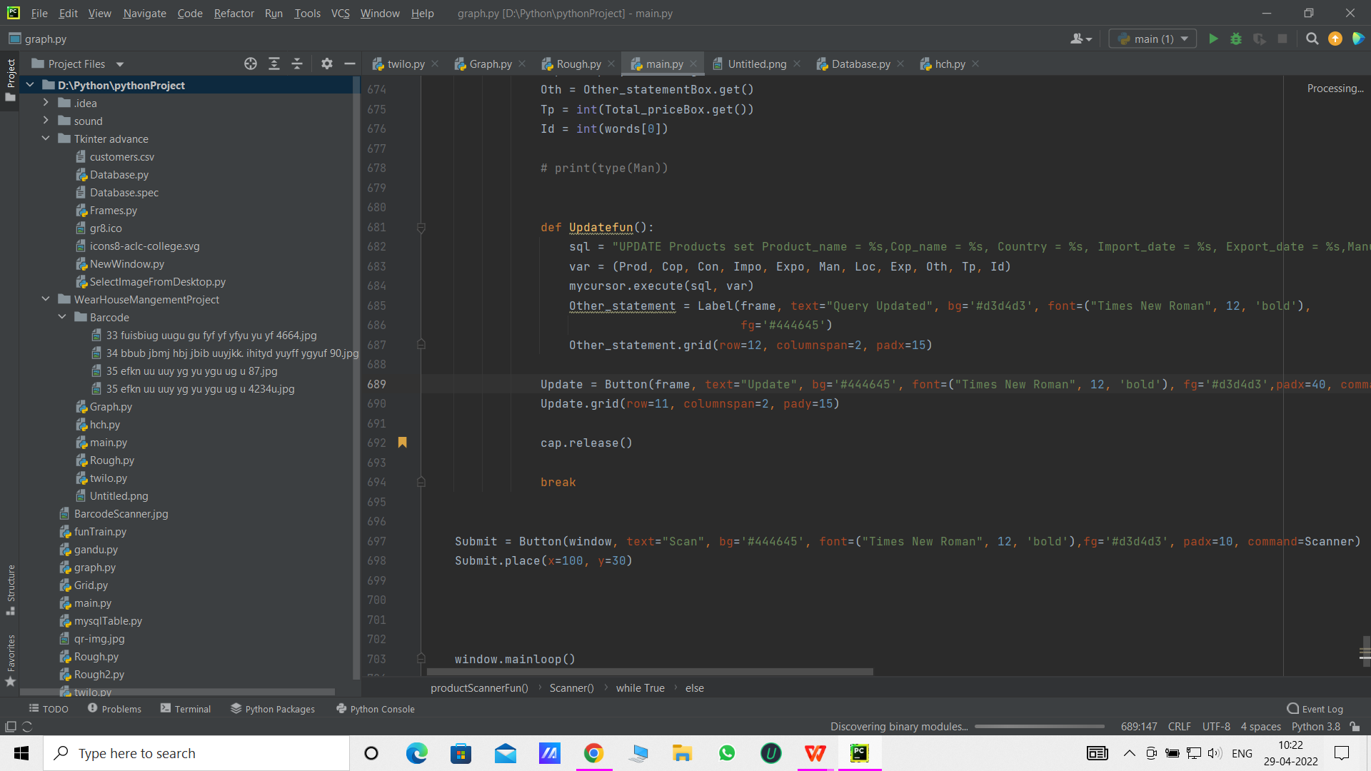

**CHAPTER 3**

**SYSTEM ANALYSIS**

1. **System Analysis**
   1. **Existing System**

Current warehouse management all work done using paper work. All files record kept on paper file. In warehouse management its very complicated to kept record and get data fast. Dealing with Oder and billing system have so much problem, Because no idea about how much product stock in wear house. Its calculate manually its so much difficult.

Deal with big data is very tough. Maintained all record in specific manner is not possible. There have no any option to automatic analysis of data and generate graph. Manually analysis the data and generate graph. All data analysis work done by manually so required time is more.

* 1. **Proposed System**

In our proposed system we proposed four module the system has no any manual work. Its has also QR code scanner so data recording make so easy.

1. **Qr code Scanner : -**

This function is used for scan the qr code for update and entry the data.

All data kept in database its easy to deal with big data and all small information to check. All small information check using QR code scanner.

1. **Generate QR code : -**

Any Product enter in warehouse before stick the QR code this qr code have information related to product. In this module want manually fill t e form and software generate the qr code for the product.

1. **Product details : -**

Product details have information related to all product data. We can easily search data. Easy to find location were data store in ware house. We easily analysis of data using graph. Easy sorted the data using graph.

1. **Employee details : -**

Employee details have store information related to employee when any employee register on this system they show data in Employee details.

* 1. **Feasibility Analysis**

**i. Technical Feasibility**

Technical aspect is the most important part in the system development. As the system is offline based, visual basic will be used to develop the interface and the functions of the database. For the database aspect, Microsoft Access will be used which will link the system interface with the data storage. The exposure gain in ‘Business System Development’ subject through course curriculum has given the author the credibility to develop the program as specified. Moreover, online tutorial on system development also vastly available on the internet which will helps author in development stage.

**ii. Economical Feasibility**

Basic analysis has been done in investigating the economical feasibility of the project. The financial analysis demonstrates that the new system will reveals a positive economic feasibility. In term of software designing and license, it can be found on open source in the Internet thus, owner does not need to purchase the software from the vendor. New system will be requiring extra cost on the hardware implementation part. Looking at current situation of the store, the owner has to purchase a desktop to use the system and also bar code scanner to scan the QRcode of the products.

In term of special staff training, the new system will not need any extra cost. Normally, newly develop system will need for special training for the user, however in this case the system the handling part is very easy and eliminate the need for training. Besides, a friendly interface makes staff work with less stress. Even though initial cost of implementation is quite high, the owner will enjoy the benefits of switching to the new system in a long term in term of efficiency and effectiveness of business operation. Firstly, they can reduce the cost or the loss incur due to overstock of food based products that have expired date. Secondly, the system also reduces the risk of having products that out of stock in the store will eventually cause the customers to find the products in other store. Besides, customers satisfactions also expected to increase as the system will provide them with proper receipt for references upon implementation. Turnover rate of each items reported by the system also helps the owner to make appropriate inventory level decision of the item precisely. Apart from all the benefits, costs related to manual works and documents required to maintain the inventory level will be reduce and eliminated gradually as all the data will be stored in the database.

**iii. Operational Feasibility**

The risk of familiarity with the application is medium because the users/staff never used to computerized system. Thus, there is a need for brief introduction on handing the system in order to implement the system. Besides, as most of the staffs in the store are not IT literate, the to-be system will be user-friendly and easy to operate.

**Administrator:** The administrator will have easier access of inventory data and update it. He prints out daily and weekly statistical report to check on the store business performance.

**The Staff:** The to-be system will ensure the transaction handle by them will directly send to database. Thus, the staff will gain advantage upon the implementation of the system as this can reduce the human- error by calculating the transaction manually and compare it with the amount of money in the cashier and the inventory level available.

**CHAPTER 4**

**SYSTEM DESIGN**

1. **System Design**

**4.1 DFDs diagrams**

A data flow diagram (DFD) maps out the flow of information for any process or system. It uses defined symbols like rectangles, circles and arrows, plus short text labels, to show data inputs, outputs, storage points and the routes between each destination. Data flowcharts can range from simple, even hand-drawn process overviews, to in-depth, multi-level DFDs that dig progressively deeper into how the data is handled. They can be used to analyze an existing system or model a new one. Like all the best diagrams and charts, a DFD can often visually “say” things that would be hard to explain in words, and they work for both technical and nontechnical audiences, from developer to CEO. That’s why DFDs remain so popular after all these years. While they work well for data flow software and systems, they are less applicable nowadays to visualizing interactive, real-time or database-oriented software or systems.

0 level Employee Database DFDs

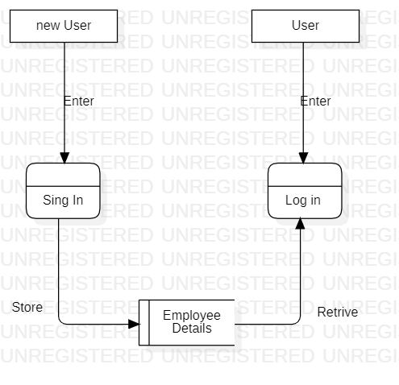

In this diagram show new user process sing in its enter all required filed and store data into Employee details table. When old user is login to data its required enter data in login process. Login process fetch data from employee details table and check information Emil id and password are match

**Product Details 0 Level DFDs**

**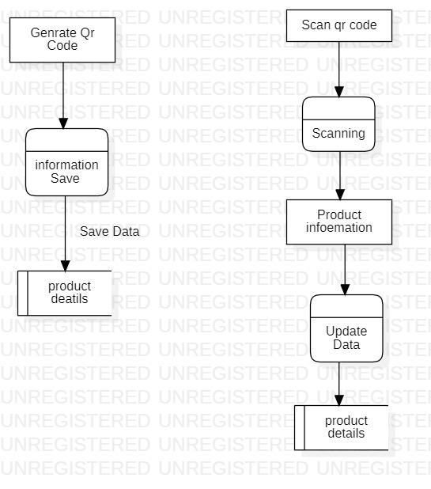**

Its Diagram show that when we generate qr code for any product this data store in database and this data use to analysis of record of product.

**Product Details 1 Level DFDs**

****

When any Product qr code scan from scanner option you will get data about this product. In this data we can update information. This information update on database also.

**4.2 UML diagrams**

A diagram is the graphical presentation of a set of elements, most often rendered as a connected graph of vertices and ares. You draw diagram to visualize a system from different perspective, so a diagram is a projection into a system. For all but most trivial systems, a diagram represents an elided view of the elements that make up a system. The same element may appear in all diagrams, only a few diagrams, or in no diagrams at all. In theory, a diagram may contain any combination of things and relationships, In practice, however, a small number of common combinations arise, which are consistent with the five most useful views that comprise the architecture of a software-intensive system. For this reason, the UML includes nine such diagrams:

**4.2.1Class Diagram**

The Class diagram is a graphical notation used to construct and visualize object oriented systems. A class diagram in the Unified Modeling Language (UML) is a type of static structure diagram that describes the structure of a system by showing the system's:

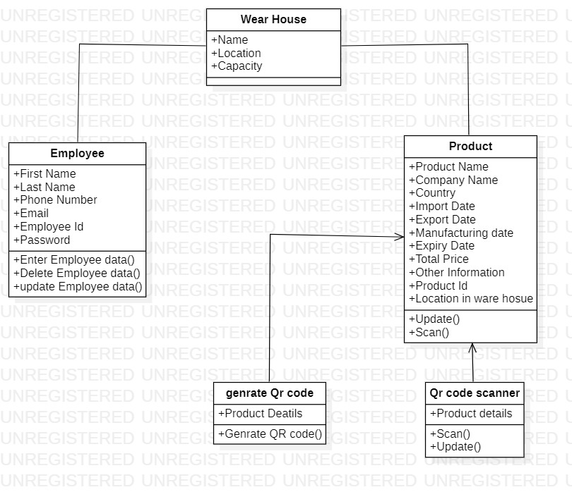

**4.2.2 Use Case Diagram**

A use case diagram in the Unified Modeling Language (UML) is a type of behavioral diagram defined by and created from a use-case analysis. Its purpose is to present a graphical overview of the functionality provided by a system in terms of actors, their goals (represented as use cases), and any dependencies between those use cases.

**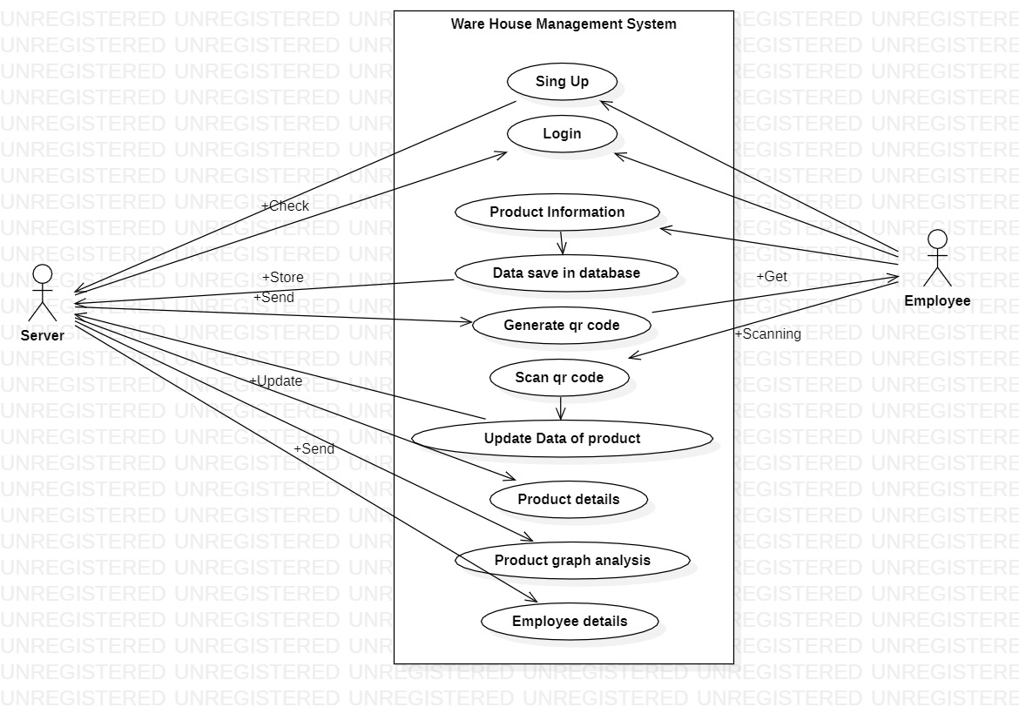**

**4.2.3 Activity Diagram**

We use Activity Diagrams to illustrate the flow of control in a system and refer to the steps involved in the execution of a use case. We model sequential and concurrent activities using activity diagrams. So, we basically depict workflows visually using an activity diagram. An activity diagram focuses on condition of flow and the sequence in which it happens. We describe or depict what causes a particular event using an activity diagram.

**Activity Diagram of Employee Login**

**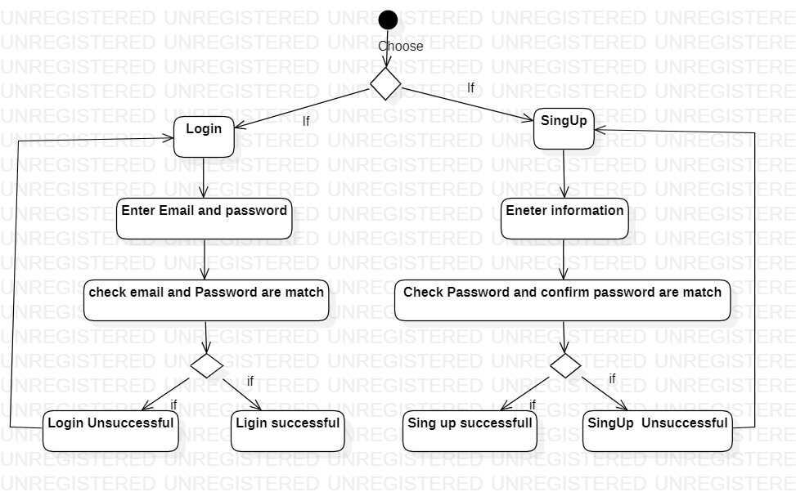**

**Activity Diagram of product Details**

**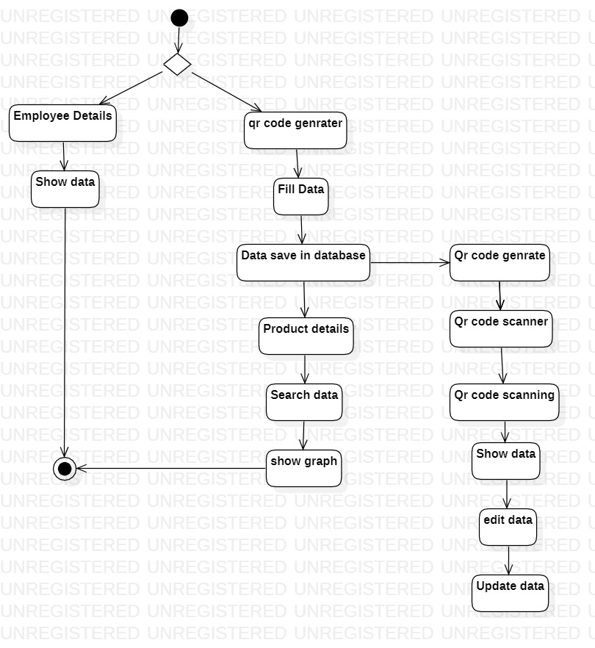**

**4.2.4 Sequence diagram**

Sequence diagrams are a popular dynamic modeling solution in UML because they specifically focus on lifelines, or the processes and objects that live simultaneously, and the messages exchanged between them to perform a function before the lifeline ends. Along with our [UML diagramming tool](https://www.lucidchart.com/pages/examples/uml_diagram_tool" \t "https://www.lucidchart.com/pages/_blank), use this guide to learn everything there is to know about sequence diagrams in UML.

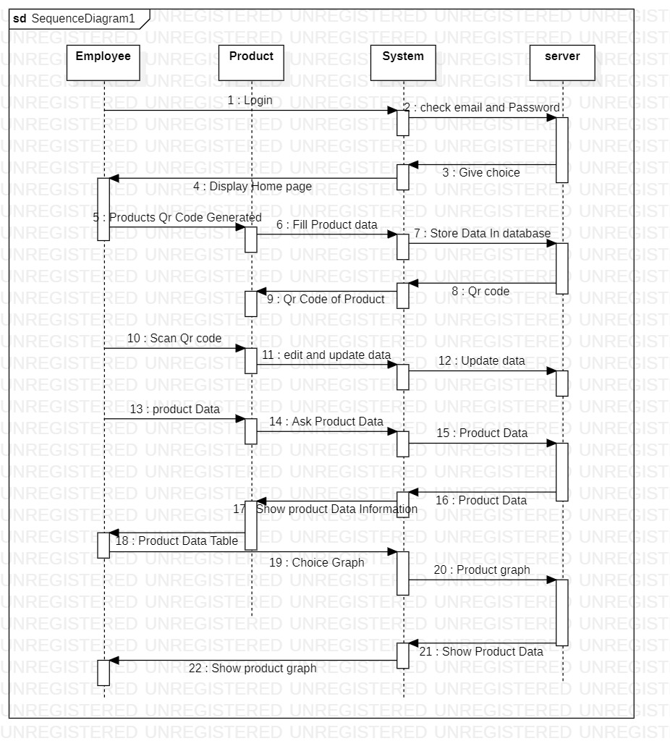

**4.2.5 Component Diagram**

[UML](https://en.wikipedia.org/wiki/Unified_Modeling_Language" \t "https://www.visual-paradigm.com/guide/uml-unified-modeling-language/what-is-component-diagram/_blank) Component diagrams are used in modeling the physical aspects of object-oriented systems that are used for visualizing, specifying, and documenting component-based systems and also for constructing executable systems through forward and reverse engineering. Component diagrams are essentially class diagrams that focus on a system's components that often used to model the static implementation view of a system.

**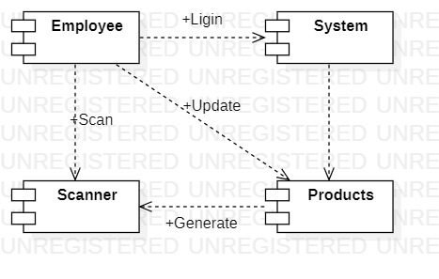**

**4.2.6 ER Diagrams**

****ER Diagram**** stands for Entity Relationship Diagram, also known as ERD is a diagram that displays the relationship of entity sets stored in a database. In other words, ER diagrams help to explain the logical structure of databases. ER diagrams are created based on three basic concepts: entities, attributes and relationships. ER Diagrams contain different symbols that use rectangles to represent entities, ovals to define attributes and diamond shapes to represent relationships.At first look, an ER diagram looks very similar to the flowchart. However, ER Diagram includes many specialized symbols, and its meanings make this model unique. The purpose of ER Diagram is to represent the entity framework infrastructure.

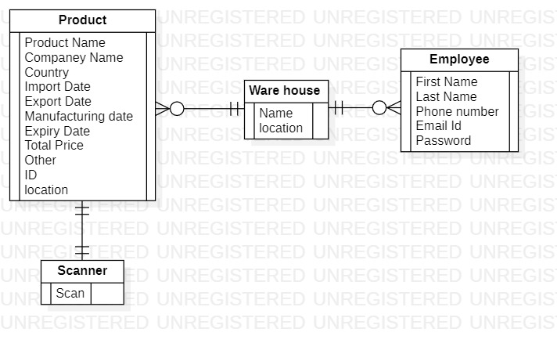

**CHAPTER 5**

**CODING**

1. **Coding**
   1. **Coding Language and module**

**5.1.1 Coding language :**

**Python** is a [high-level](https://en.wikipedia.org/wiki/High-level_programming_language" \o "High-level programming language), [interpreted](https://en.wikipedia.org/wiki/Interpreter_(computing)" \o "Interpreter (computing)), [general-purpose programming language](https://en.wikipedia.org/wiki/General-purpose_programming_language" \o "General-purpose programming language). Its design philosophy emphasizes [code readability](https://en.wikipedia.org/wiki/Code_readability" \o "Code readability) with the use of [significant indentation](https://en.wikipedia.org/wiki/Off-side_rule" \o "Off-side rule). Its [language constructs](https://en.wikipedia.org/wiki/Language_construct" \o "Language construct) and [object-oriented](https://en.wikipedia.org/wiki/Object-oriented_programming" \o "Object-oriented programming) approach aim to help [programmers](https://en.wikipedia.org/wiki/Programmers" \o "Programmers) write clear, logical code for small- and large-scale projects.

Python is [dynamically-typed](https://en.wikipedia.org/wiki/Type_system" \l "DYNAMIC" \o "Type system) and [garbage-collected](https://en.wikipedia.org/wiki/Garbage_collection_(computer_science)" \o "Garbage collection (computer science)). It supports multiple [programming paradigms](https://en.wikipedia.org/wiki/Programming_paradigm" \o "Programming paradigm), including [structured](https://en.wikipedia.org/wiki/Structured_programming" \o "Structured programming) (particularly [procedural](https://en.wikipedia.org/wiki/Procedural_programming" \o "Procedural programming)), object-oriented and [functional programming](https://en.wikipedia.org/wiki/Functional_programming" \o "Functional programming). It is often described as a "batteries included" language due to its comprehensive [standard library](https://en.wikipedia.org/wiki/Standard_library" \o "Standard library).

[Guido van Rossum](https://en.wikipedia.org/wiki/Guido_van_Rossum" \o "Guido van Rossum) began working on Python in the late 1980s as a successor to the [ABC programming language](https://en.wikipedia.org/wiki/ABC_(programming_language)" \o "ABC (programming language)) and first released it in 1991 as Python 0.9.0.[]](https://en.wikipedia.org/wiki/Python_(programming_language)" \l "cite_note-33) Python 2.0 was released in 2000 and introduced new features such as [list comprehensions](https://en.wikipedia.org/wiki/List_comprehension" \o "List comprehension), [cycle-detecting](https://en.wikipedia.org/wiki/Cycle_detection" \o "Cycle detection) garbage collection, [reference counting](https://en.wikipedia.org/wiki/Reference_counting" \o "Reference counting), and [Unicode](https://en.wikipedia.org/wiki/Unicode" \o "Unicode) support. Python 3.0, released in 2008, was a major revision that is not completely [backward-compatible](https://en.wikipedia.org/wiki/Backward_compatibility" \o "Backward compatibility) with earlier versions. Python 2 was discontinued with version 2.7.18 in 2020.

**5.1.2 Module :**

**A. [Tkinter](https://docs.python.org/3/library/tkinter.html" \l "module-tkinter" \o "tkinter: Interface to Tcl/Tk for graphical user interfaces)**

The [tkinter](https://docs.python.org/3/library/tkinter.html" \l "module-tkinter" \o "tkinter: Interface to Tcl/Tk for graphical user interfaces) package (“Tk interface”) is the standard Python interface to the Tcl/Tk GUI toolkit. Both Tk and [tkinter](https://docs.python.org/3/library/tkinter.html" \l "module-tkinter" \o "tkinter: Interface to Tcl/Tk for graphical user interfaces) are available on most Unix platforms, including macOS, as well as on Windows systems. Running python -m tkinter from the command line should open a window demonstrating a simple Tk interface, letting you know that [tkinter](https://docs.python.org/3/library/tkinter.html" \l "module-tkinter" \o "tkinter: Interface to Tcl/Tk for graphical user interfaces) is properly installed on your system, and also showing what version of Tcl/Tk is installed, so you can read the Tcl/Tk documentation specific to that version. Tkinter supports a range of Tcl/Tk versions, built either with or without thread support. The official Python binary release bundles Tcl/Tk 8.6 threaded. See the source code for the \_tkinter module for more information about supported versions. Tkinter is not a thin wrapper, but adds a fair amount of its own logic to make the experience more pythonic. This documentation will concentrate on these additions and changes, and refer to the official Tcl/Tk documentation for details that are unchanged.

# Pillow (a fork of PIL)

Python Imaging Library (expansion of PIL) is the de facto image processing package for Python language. It incorporates lightweight image processing tools that aids in editing, creating and saving images. Support for Python Imaging Library got discontinued in 2011, but a project named pillow forked the original PIL project and added Python3.x support to it. Pillow was announced as a replacement for PIL for future usage. Pillow supports a large number of image file formats including BMP, PNG, JPEG, and TIFF. The library encourages adding support for newer formats in the library by creating new file decoders.

# MySQL-Connector-Python

MySQL is a Relational Database Management System (RDBMS) whereas the structured Query Language (SQL) is the language used for handling the RDBMS using commands i.e Creating, Inserting, Updating and Deleting the data from the databases. SQL commands are case insensitive i.e CREATE and create signify the same command.

In this article, we will be discussing the MySQL Connector module of Python, how to install this module and a piece of code on how to connect this with the MySQL database. For any application, it is very important to store the database on a server for easy data access.

MySQL Connector/Python enables Python programs to access MySQL databases, using an API that is compliant with the Python Database API Specification v2.0 (PEP 249). It is written in pure Python and does not have any dependencies except for the Python Standard Library.

1. **Qrcode**

Qrcode module is a QR code generator. The module automates most of the building process for creating QR codes. This module attempts to follow the QR code standard as closely as possible. The terminology and the encodings used in pyqrcode come directly from the standard.

1. **Cv2**

OpenCV is the huge open-source library for computer vision, machine learning, and image processing and now it plays a major role in real-time operation which is very important in today’s systems. By using it, one can process images and videos to identify objects, faces, or even the handwriting of a human. When it integrated with various libraries, such as Numpuy, python is capable of processing the OpenCV array structure for analysis. To Identify image patterns and its various features we use vector space and perform mathematical operations on these features.

1. **Numpy**

NumPy, which stands for [Numerical Python](https://www.mygreatlearning.com/blog/python-numpy-tutorial/" \t "https://www.mygreatlearning.com/blog/python-numpy-tutorial/_blank), is a library consisting of multidimensional array objects and a collection of routines for processing those arrays. Using NumPy, mathematical and logical operations on [arrays](https://www.mygreatlearning.com/blog/what-is-an-array-learn-more-in-one-read/" \t "https://www.mygreatlearning.com/blog/python-numpy-tutorial/_blank)can be performed. NumPy is a Python package. It stands for ‘Numerical Python’. It is a library consisting of multidimensional array objects and a collection of routines for processing of array.

NumPy is often used along with packages like [SciPy](https://www.mygreatlearning.com/blog/scipy-tutorial/" \t "https://www.mygreatlearning.com/blog/python-numpy-tutorial/_blank)(Scientific Python) and [Matplotlib](https://www.mygreatlearning.com/academy/learn-for-free/courses/python-matplotlib?post=23244" \t "https://www.mygreatlearning.com/blog/python-numpy-tutorial/_blank)(plotting library). This combination is widely used as a replacement for MatLab, a popular platform for technical computing. However, Python alternative to MatLab is now seen as a more modern and complete programming language. It is open-source, which is an added advantage of NumPy. The most important object defined in NumPy is an N-dimensional array type called **ndarray**. It describes the collection of items of the same type. Items in the collection can be accessed using a zero-based index.

# Python pyzbar

In this tutorial we will check how to detect and decode a barcode in an read the original image. We will start by importing the **cv2**module, so we can read our testing image as a **numpy** array. We will also import the **decode**function from the **pyzbar** module, which we will use to detect and decode the barcode.

1. **Matplotlib**

Matplotlib is an amazing visualization library in Python for 2D plots of arrays. Matplotlib is a multi-platform data visualization library built on NumPy arrays and designed to work with the broader SciPy stack. It was introduced by John Hunter in the year 2002.

One of the greatest benefits of visualization is that it allows us visual access to huge amounts of data in easily digestible visuals. Matplotlib consists of several plots like line, bar, scatter, histogram etc.

* 1. **Function in code**

1. **Sing up**

This function is used for sing up the employee. When Any employee is click on Sing up new window is open. In this window fill all field is important. When employee click on Register button the function first check password and confirm password are match or not. When password and confirm password is match then its data store in database.

1. **SingUpClick**

Sing Up Click is button function in sing up function its help store data in database. And check Password is match or not

1. **Login**

Login function have two filed Email id and Password when correct Email ld and password is insert they process to next window. Its check Password and email id match using database store data.

1. **Home**

Home is main and important function its home screen in software system its have four option to choose employee Employee Details, Product details, Qr code Generate and qr code scanner.When employee click on the any option the new window will open.

1. **EmployeeDetailsFun**

In employee details function generate table using database employee information. This table have information related to Employee.

1. **GenQrCode**

In this function have generate qr code using the filling field information and store this information in database also

1. **Adddatabase**

This function is inside function on GenQrCode its helps to store data in database.

1. **ProductDetailsFun**

In this have so much option for user to analysis the data. There have table which have display all record of product information. There have also search bar to search any information.

1. **SearchFun**

Search fun is function inside Product details. Its search data from database table and show in table.

1. **ProductVsPiceFun**

This function inside ProductDetailsFun its create Product vs price graph using database information.

1. **CompneyVsPrice**

This function inside ProductDetailsFun its create Product vs price graph using database information.

1. **CountryVsPrice**

This function inside ProductDetailsFun its create Product vs price graph using database information.

1. **ProductScannerFun**

When user click on Product Scan the new window will create there have option to scan and update data.

1. **Scanner**

Its function inside the ProductScannerFun function.n Scan the Qr code and show data in window.

1. **UpdateFun**

Its function inside the ProductScannerFun function. Scanning data show in Entry filed as user want update this data this data is update on database table.

* 1. **Database SQL Query**

There have two tables employee and product table

**5.3.1 Employee table :**

first\_name : Varchar (255)

last\_name : Varchar(255)

phone\_no : int(15)

Email: varchar(255)

employee\_id : Auto increment int(255) Primary Key

Password : varchar(255)

**5.3.2 Products table :**

Product\_name : Varchar(255)

Cop\_name : Varchar(255)

Country : Varchar(255)

Import\_date : Date

Export\_date : Date

Manufacturing\_date : Date

Expiry\_date : Date

Total\_price : int(255)

Other : Varchar(255)

Product\_id : Auto increment int(255) Primary Key

Location : Varchar(255)

**CHAPTER 6**

**TESTING**

1. **Testing** 
   1. **Test login employee**

|  |  |  |
| --- | --- | --- |
| **Employee Email** | **Employee Password** | **Result** |
| Bjnaik@gmail.com | 123 | Pass |
| JordenAbraham565gmail.com | JordenAbraham123 | Pass |
| ddnsan@gmail.com | 123456 | Pass |

When enter wrong password

|  |  |  |
| --- | --- | --- |
| **Employee Email** | **Employee Password** | **Result** |
| Bjnaik@gmail.com | 12 | Pass |
| JordenAbraham565gmail.com | Jobraham123 | Pass |
| ddnsan@gmail.com | 123 | Pass |

* 1. **Generate Qr Code**

|  |  |  |
| --- | --- | --- |
| **Data Id** | **Qr Code** | **Result** |
| 35 | Qr Code Generated | Pass |
| 38 | Qr Code Generated | Pass |
| 468 | Qr Code Generated | pass |

* 1. **Scan Qr code**

|  |  |  |
| --- | --- | --- |
| **Scan Qr Code** | **Fetch ID** | **Result** |
| Scanned | 455 | Pass |
| Scanned | 689 | Pass |
| Scanned | 842 | Pass |
| Scanned | 83 | Pass |
| Scanned | 57 | Pass |

**CHAPTER 7**

**OUTPUT SCREENS**

1. **Output Screens**

**7.1 Home Page**

**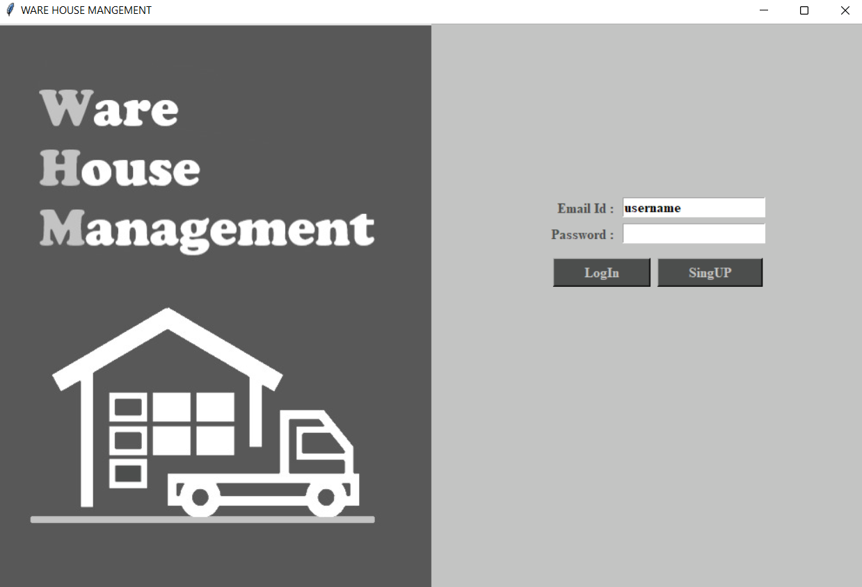**

**7.2 SingUp Page**

**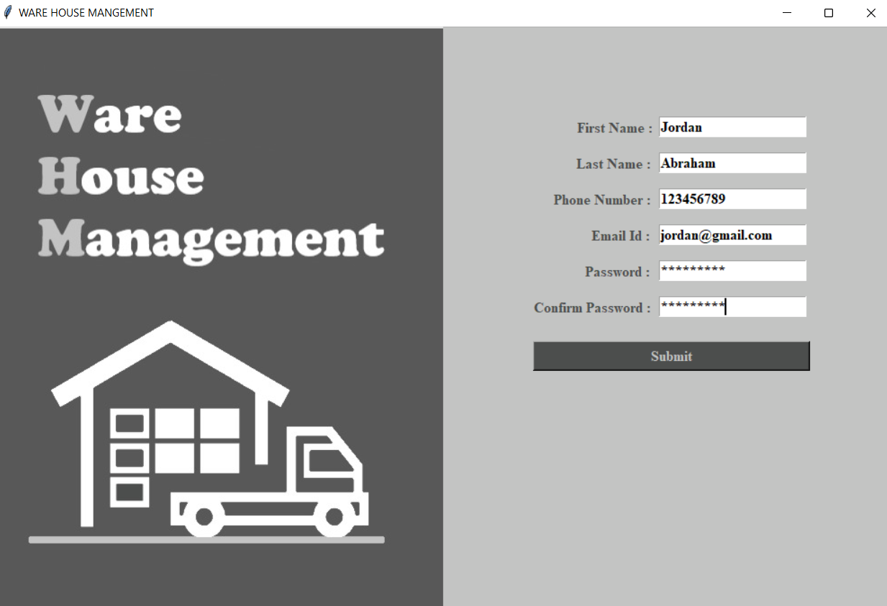**

**7.3 LogIn page**

**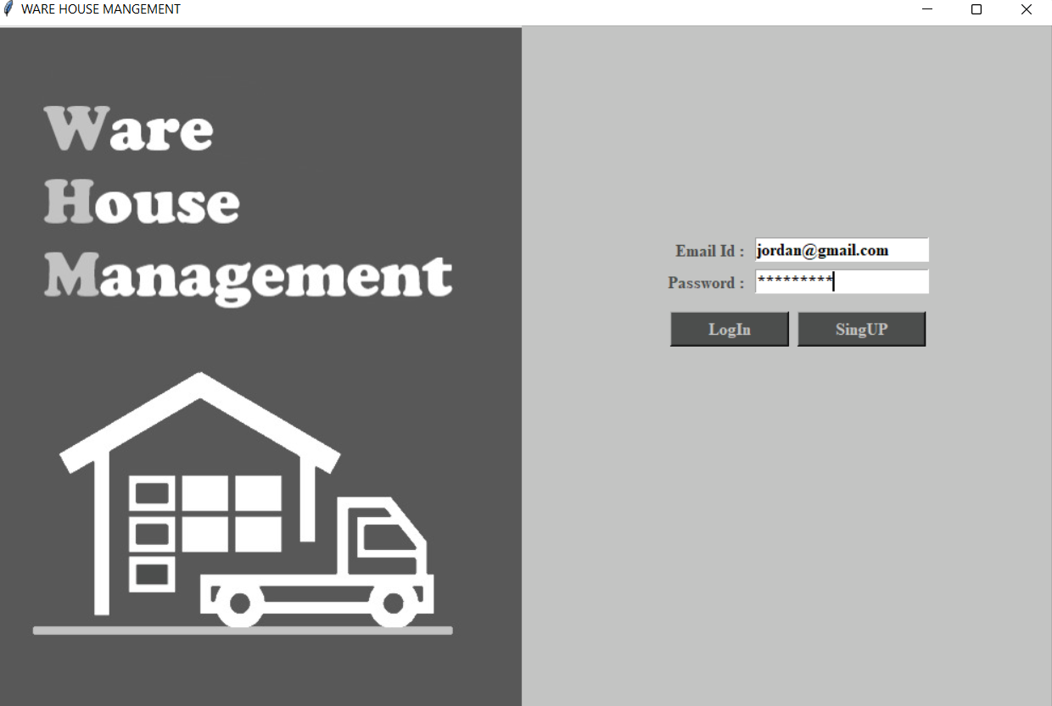**

**7.4 Main Home Screen**

**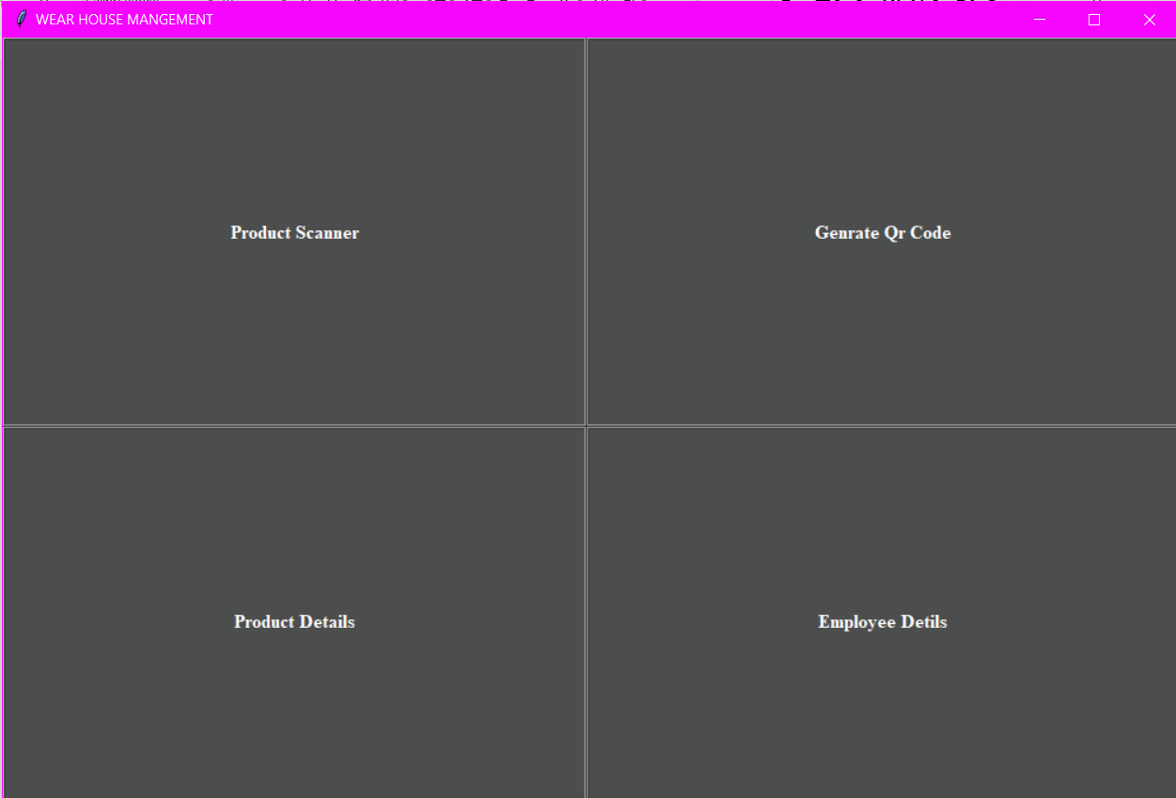**

**7.5 Product Scanner Screen**

**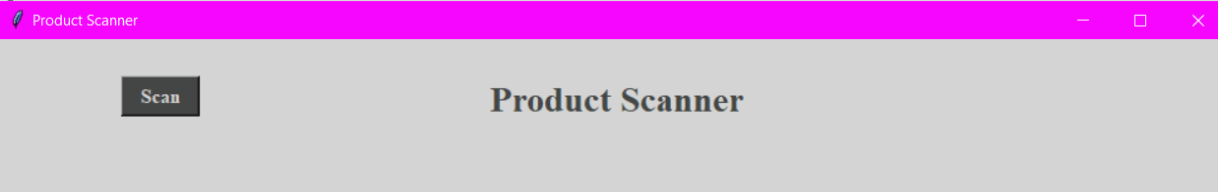**

**7.6 Scanning Screen**

**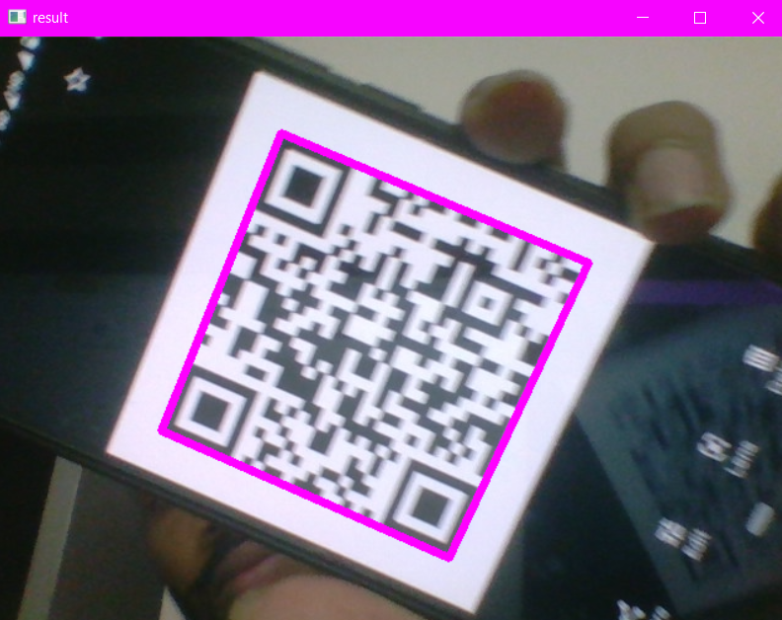**

**7.7 Scanned Data**

**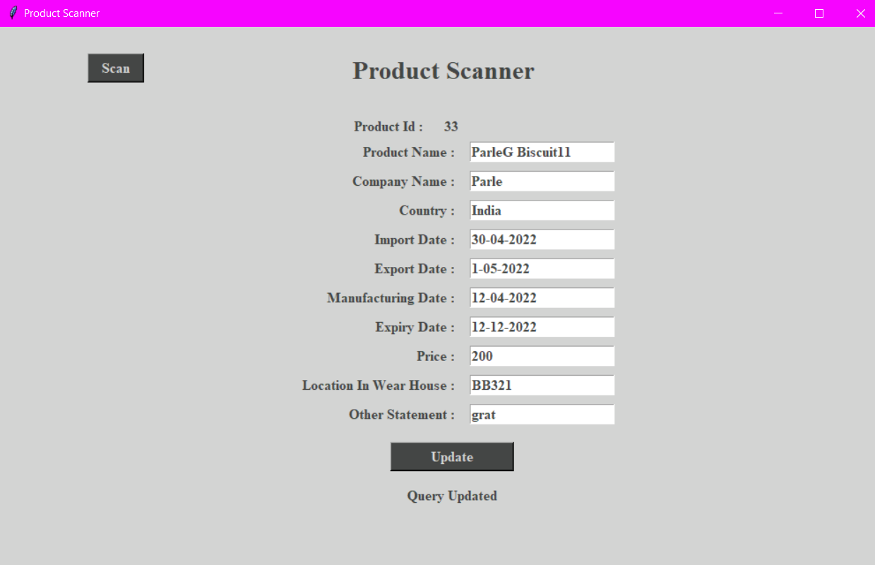**

**7.8 Generate QR Code field**

**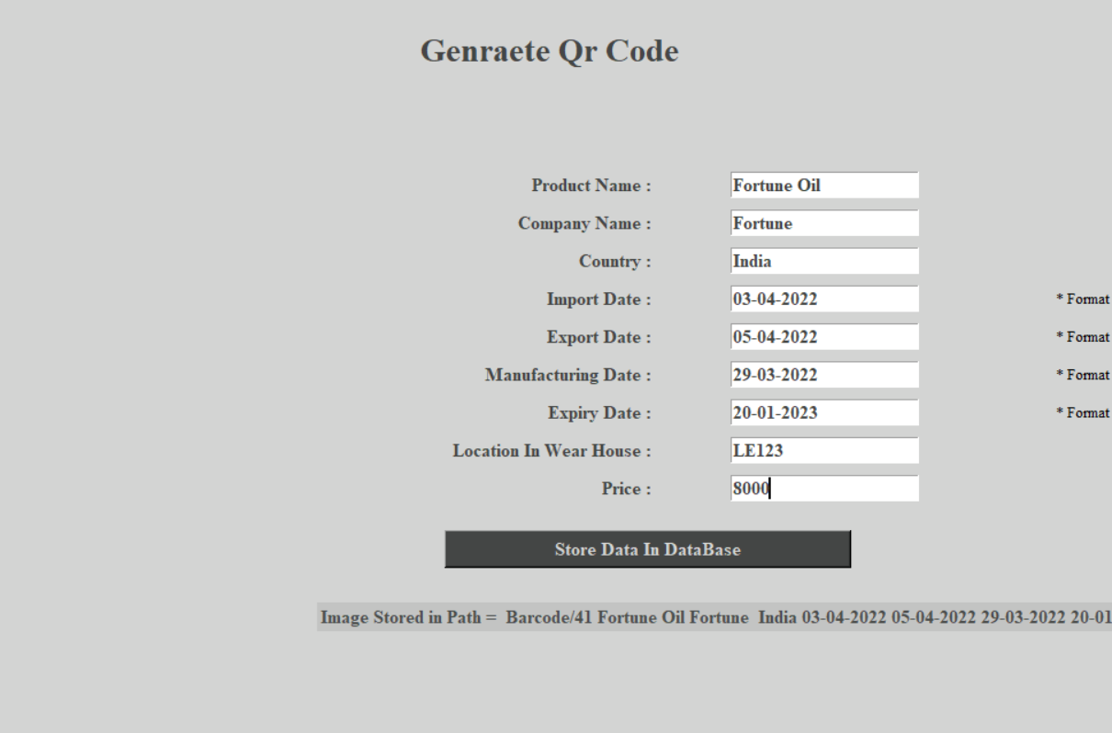**

**7.9 Generate QR code**

****

**7.10 Employee Details**

**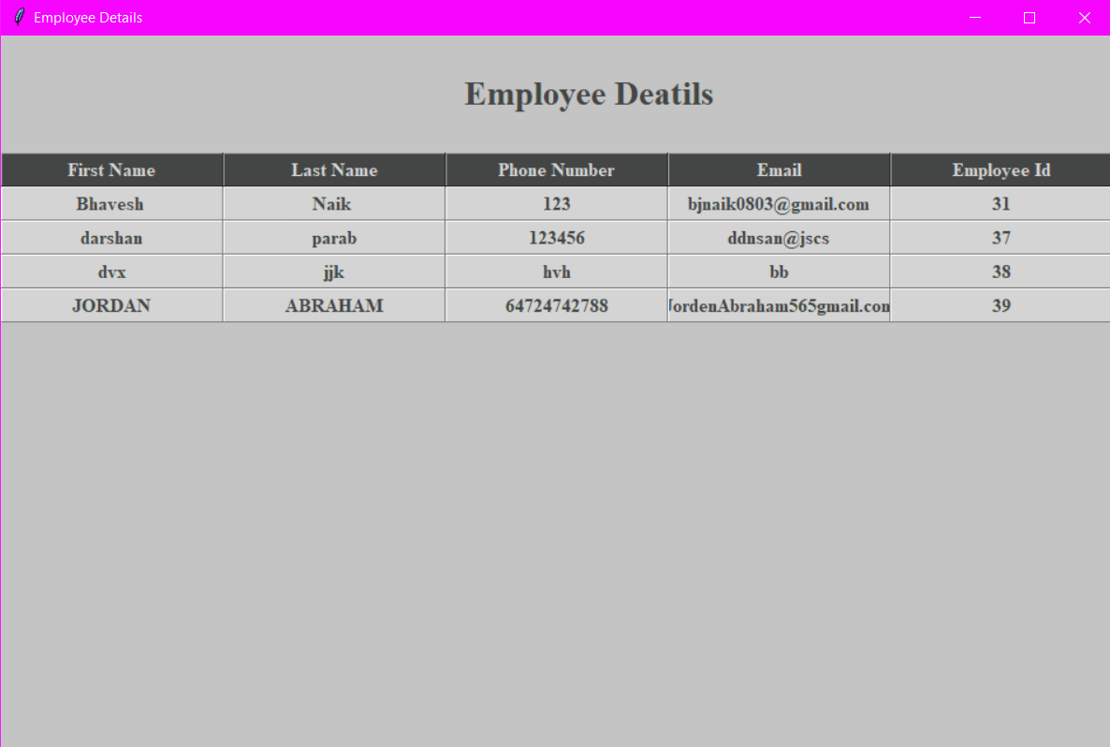**

**7.11 Product details**

**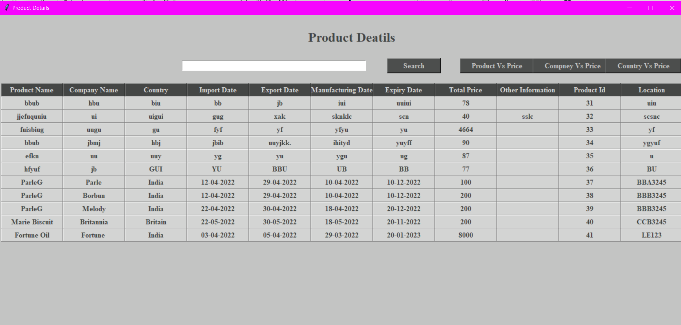**

**7.12 Product details search company name**

**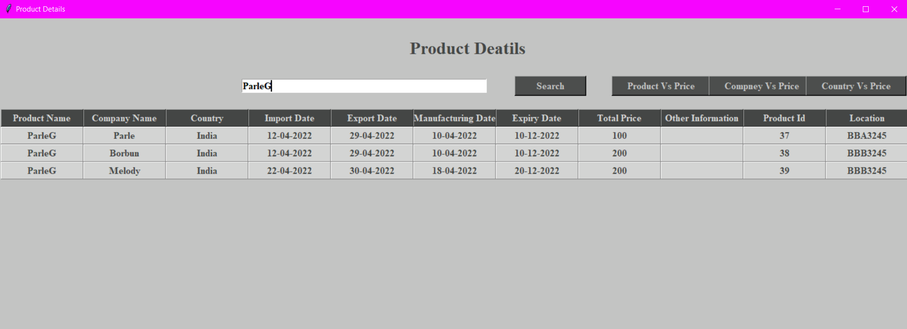**

**7.13 Product details search Product name**

**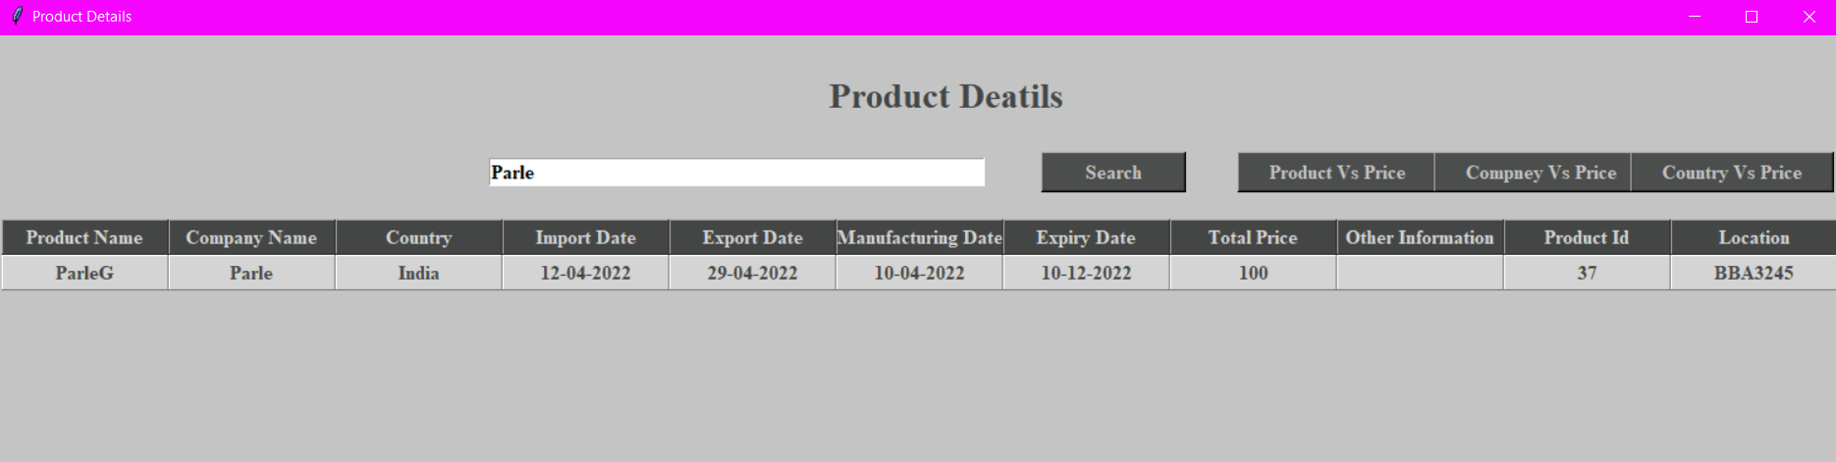**

**7.14 Graphical representation of graphical view**

**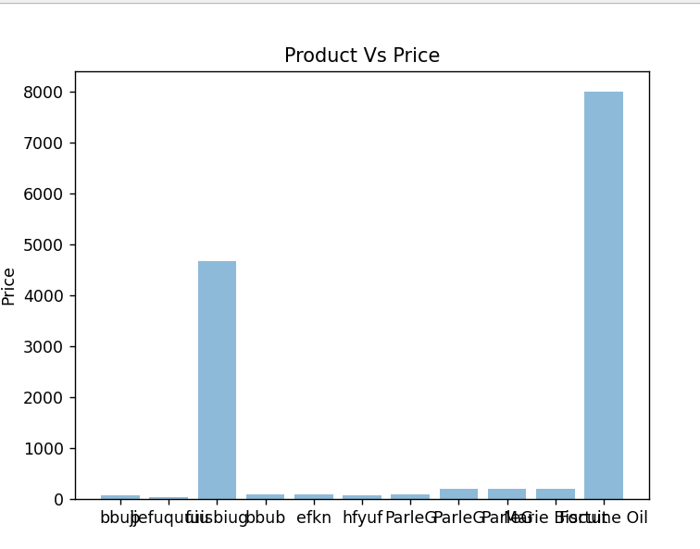**

**CHAPTER 8**

**CONCLUSION**

1. **Conclusion**

Warehouses in highly developed countries will no doubt adopt the latest technology, and companies whose products can absorb the high initial capital investment will be at the forefront of warehouse automation.

However, as discussed previously, automation is not for everyone, and warehouses will continue to hold stock and employ staff to receive, put away, pick and despatch products. It is hoped that this book has given you, the reader, an insight into warehouse operations in the 21st century. Although investment in technology will improve and speed up operations, changes in processes, attitudes and improved communication both internally and externally are the stepping stones. These need to be firmly in place and cannot be by-passed under any circumstances prior to any thoughts of automation.

The growth in e-commerce will continue to challenge warehouse managers globally and the change in profile from full-carton and full-pallet picks to individual-item picks will have equipment manufacturers seeking the holy grail of pick systems. Whatever that may be. One thing is certain: we cannot afford to stand still. US Rear Admiral Grace Hopper (1906–92) once said, ‘The most damaging phrase in the language is: “It’s always been done that way.”’ This is a statement I have heard many times in my career and therefore I hope this book has given you some new ideas to think about and hopefully you will be able to implement them and they will help you improve efficiency and minimize costs.

In warehousing management, existing transaction data is required for accuracy and speed in processing using a system. Warehouse management system is an essential replacement for a manual management system. The main purpose of automating the warehouse system is to control the movement and storage of the products, together with the benefit of enhanced security and quicker handling. Currently, the stored data can be organized according to serial number, activated easily assuring the FIFO concept, and handed to the dealers accurately with the least amount of possible errors. Warehouse Management System System is now a necessity because it can improve warehouse efficiency and accuracy, thus providing solutions to problems that exist in the warehouse. And also the warehouse system has become more reliable and efficient after the automation, simplifying the process for the operators, the supplier and the dealers

**CHAPTER 9**

**FUTURE ENHANCEMENT**

1. **Further Enhancements**
2. Its new future work is in single window change with frame
3. Add transport system data also.
4. I ware house system required to read also other qr code and get information
5. More attractive icon use instead of name.
6. Searching bar and table also want more fast and delete old searches.
7. In employee details give option delete and update

**BILIOGRAPHY**

**Bibliography**

* <https://budi.rahardjo.id/files/courses/2020/DL-023201905028-Report-Heru-Rev1.pdf>
* <https://aspnet.cob.ohio.edu/isms/upload/documents/10867_635355682482963914_Ferrari_Order_Receiving_SDLC_Document.pdf>
* <https://www.academia.edu/29551668/Documentation_on_Warehouse_Management_System>
* <https://docs.google.com/document/d/1eau1fZta6PEXmqIoBgOkqKcm6xcXlwcv/edit>
* <https://www.freeprojectz.com/project-report/14377>
* <https://www.geeksforgeeks.org/python-introduction-matplotlib/>
* <https://techtutorialsx.com/2020/01/01/python-pyzbar-detecting-and-decoding-barcode/>
* <https://www.mygreatlearning.com/blog/python-numpy-tutorial/>
* <https://www.geeksforgeeks.org/python-introduction-matplotlib/>